Project Design Phase
Solution Architecture

Date | 28 September 2026
Team ID | SWTID-2026-3622
Project Name | Import Data Using Transform Maps
Maximum Marks | 4 Marks

- Executive Solution Architecture Overview
​The Solution Architecture bridges the gap between raw external employee data and structured ServiceNow platform intelligence. It outlines an automated data pipeline that handles ingestion, field transformation, record deduplication, security configuration, and real-time visualization on custom dashboards.

- Textual Architecture & Data Flow Diagram
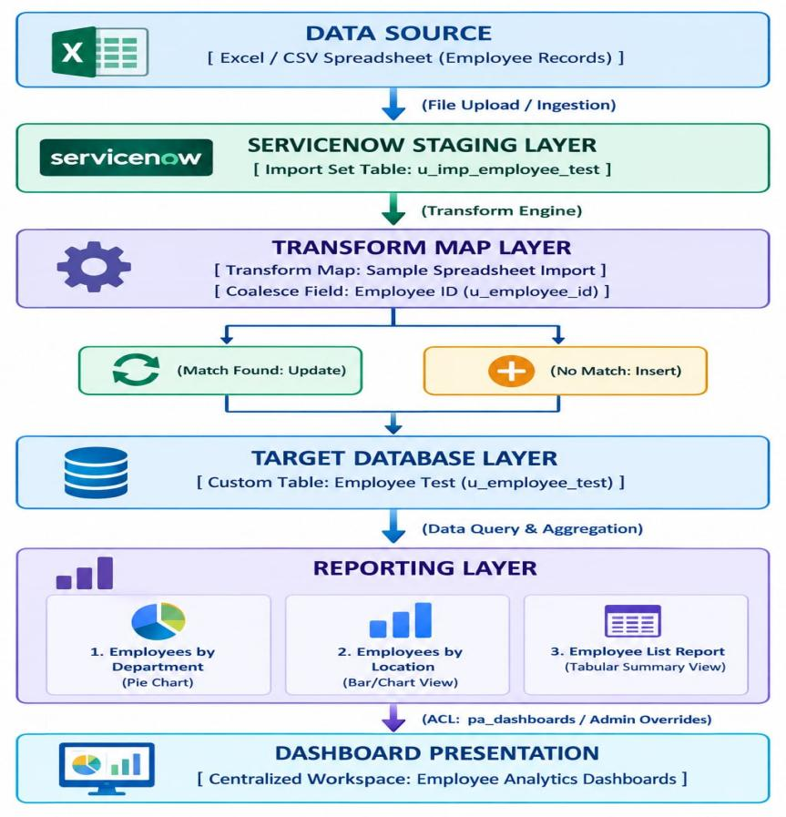

3. Architecture Component Specifications

​1. Ingestion Layer (Import Sets)
- Input Interface: Excel/CSV spreadsheet upload interface.
- Staging Table: Temporary holding table (u_imp_employee_test) created by ServiceNow to store raw uploaded rows prior to database commit.
​2. Processing & Business Logic Layer (Transform Maps)
Transform Map Name: Sample Spreadsheet Import.
Field Map Pairs: Maps raw source fields (Employee ID, Name, Email, Department, Location) to target schema columns.
Deduplication Engine (Coalesce): Configured with Coalesce = True on the primary key Employee ID.
- Match Behavior: Updates existing record row.
- No Match Behavior: Inserts new record row.
- Identical Re-import Behavior: Ignores incoming duplicate records.
​3. Data Persistence Layer (Target Schema)
- Target Table: Employee Test (u_employee_test).
- Data Integrity: Ensures zero redundant rows and clean system records across multiple execution runs.
​4. Security & Access Control Layer (ACL)
- Access Control Rule: Configured on table pa_dashboards.
- Operation: create.
- Security Override: Enabled Admin Overrides = True to grant backend creation access via PA_DASHBOARDS.FORM.
​5. Analytics & Visualization Layer (Reports & Dashboards)
​Reporting Engine:
- Employees by Department: Pie chart grouped by Department with Count aggregation.
- Employees by Location: Visual allocation report by geographic area.
- Employee List Report: Detail grid summarizing active employee records.
Dashboard Container: Centralized workspace created as Employee Analytics Dashboards integrating all report widgets side-by-side.

